Research Proposal 1
A. BASIC INFORMATION
Project Title: Development of FIRA: Web-Based Recruitment Platform for Fil International Recruitment Agency with Applicant Tracking and SBERT-Based Candidate-Job Matching
Keywords: web-based recruitment platform; international recruitment agency; applicant tracking system; candidate-job matching; Sentence-BERT; semantic similarity; natural language processing
Proponents: III – DCSAD | GROUP 6 - XLR8
B. TECHNICAL DESCRIPTION
Project Context
Recruitment has changed because of digital technology and artificial intelligence (AI) nowadays. Many organizations now use AI tools to help with sourcing applicants, screening resumes, communicating with candidates, onboarding, and other human resource tasks. Studies also show that recruitment involves large amounts of text, repeated decision-making, and coordination among different people, which makes it a suitable area for digital systems. Because of this, web-based recruitment platforms have become important since they can bring together job posting, applicant submission, status tracking, and decision support in one system (Madanchian, 2024; Tusquellas et al., 2024).

One important part of modern recruitment systems is candidate-job matching. In the past, many systems relied mostly on keyword searching. However, recent studies show that newer recruitment systems now use semantic matching, skill extraction, recommender system techniques, and person-job fit models to compare resumes and job descriptions in a more meaningful way. Researchers also point out that matching accuracy alone is not enough. A recruitment platform must also support document submission, employer requirements, and workflow tracking. This is especially important for international recruitment agencies because they handle many applicants, employers, and staff members across several stages of the recruitment process (Akkasi, 2024; Çelik Ertuğrul & Bitirim, 2025; Mashayekhi et al., 2024).

Even with these developments, many recruitment processes are still fragmented. In many cases, company websites only provide basic information, while applicant registration, resume submission, vacancy posting, and recruitment monitoring are handled in separate ways. This setup can slow down screening, make communication harder, and create difficulty in comparing applicants fairly and consistently across job openings. For an international recruitment agency, this problem becomes more serious because the system must support applicants, employers, and agency staff at the same time while keeping the recruitment process organized and traceable. Because of this, the present study proposes a web-based recruitment platform that combines public websites, applicant tracking, and intelligent candidate-job matching into one system.

Recent studies also support the value of this kind of platform. Horodyski (2023) found that applicants generally had positive views of AI in recruitment, especially when it helped reduce response time and was easy to use. Ligeiro et al. (2024) also reported that trust, novelty, and organizational attractiveness affect how willing candidates are to engage with AI-supported recruitment. On the recruiter side, Almeida et al. (2025) found that acceptance of AI tools depends strongly on usefulness and ease of use. These findings suggest that an intelligent recruitment platform can be effective if it is not only technically capable, but also understandable, usable, and supportive of human decision-making.

However, the literature shows that intelligent recruitment systems also face important challenges. Resumes and job descriptions are often unstructured and written in different formats, which makes information extraction and comparison difficult without strong text-processing methods (Akkasi, 2024). In addition, recruitment recommender systems raise concerns about fairness, legal compliance, and governance because ranking results may affect access to employment opportunities (Kumar et al., 2023). More recent studies further show that automated matching may reflect bias related to gender, race, and education, while explainability and the ability to question system decisions remain important for responsible use (Hadžić et al., 2025; Iso et al., 2025; Zhang et al., 2025). For this reason, the study does not simply aim to build a company website. Instead, it aims to develop an integrated recruitment platform where semantic matching is used as decision support within an applicant tracking process that still includes human oversight.

Objective of the Study
This study aims to design, develop, and evaluate a web-based recruitment platform for an international recruitment agency that integrates public websites, an Applicant Tracking System (ATS), and intelligent candidate-job matching using SBERT-based semantic similarity.

General Objective
The general objective of the study is to develop a web-based recruitment platform for an international recruitment agency that supports applicants, employers, and agency staff through applicant registration, employer job posting, applicant tracking, and SBERT-based candidate-job matching.
Specific Objectives
- Analyze the existing recruitment workflow, information requirements, and pain points associated with applicant management, employer coordination, and agency staff operations.
- Review recent literature and relevant systems on e-recruitment, applicant tracking, semantic matching, fairness, and AI-enabled hiring to guide the system design.
- Design the system architecture, database structure, and role-based workflows for the public website, applicant module, employer module, and agency staff module.
- Develop the applicant module with features for account registration, profile completion, resume upload, agency form download and submission, job browsing, and application tracking.
- Develop the employer module with features for account registration, company profile management, job posting, requirement specification, and review of matched or endorsed applicants.
- Develop the agency staff module with dashboard functionalities for applicant verification, vacancy management, ATS status updates, candidate endorsement, and report generation.
- Implement an SBERT-based candidate-job matching module that preprocesses textual inputs, generates semantic embeddings, computes similarity scores, and ranks candidates or jobs according to relevance.
- Test the system using functional test cases and evaluate selected software quality characteristics based on ISO/IEC 25010, particularly functional suitability, usability, performance efficiency, and reliability.
- Prepare the prototype for deployment and produce the corresponding technical documentation, evaluation results, and user guidelines for academic and organizational use.

Scope and Limitations

Scope
The study covers the design and development of a web-based recruitment platform intended for the operational context of an international recruitment agency based in the Philippines, with online access for applicants, employers, and agency staff. The platform will include a public-facing website layer composed of the websites components such as: Home, About, FAQ, News, Contact, and Job Search pages; a recruitment management layer composed of applicant, employer, and agency staff modules; and an intelligent matching layer composed of semantic candidate-job matching and ranking. The proposed system will support applicant registration, profile completion, resume upload, agency form download and submission, employer job posting, job-requirement encoding, applicant endorsement, generate report, and ATS-based status monitoring.

Utilization of the Algorithm
The core intelligent function of the study is the use of Sentence-BERT (SBERT) embeddings and similarity scoring to compare applicant data with job requirements. Textual inputs may include resume content, profile information, job descriptions, and encoded skills or qualification fields. The matching component will serve as decision support for shortlisting and recommendation; final selection decisions will remain under the authority of agency staff and employers.

List of System Features
The study includes the following major system features:
(a) public information pages for organizational presentation and job exploration;
(b) applicant registration and login;
(c) applicant profile completion and document submission;
(d) employer registration, company profile management, and job posting;
(e) agency staff dashboard for recruitment administration;
(f) Applicant Tracking System (ATS) for status monitoring;
(g) SBERT-based candidate-job matching and ranking;
(h) searchable and filterable job listings;
(i) basic reporting and dashboard visualization; and
(j) role-based authentication and account management.

Geographical Scope
The geographical scope of the study is the operational context of an international recruitment agency in the Philippines and its online interactions with overseas employers and applicants. Data gathering, consultation, and evaluation activities are expected to be conducted primarily within this context.

Temporal Scope
Data collection, system development, and evaluation will be conducted during Academic Year 2025–2026 to Academic Year 2026–2027.

Tools for System Design and Development
The proposed system may be developed using the following tools and technologies:
(a) React.js with Vite, HTML5, CSS3, and Tailwind CSS for the front-end interface;
(b) Node.js with Express.js for web services and business logic;
(c) Python 3.11 with the sentence-transformers library for SBERT embedding generation and cosine similarity computation;
(d) PostgreSQL for structured data storage;
(e) RESTful APIs and JSON-based data exchange; and
(f) Git-based version control for collaborative development and maintenance.

Limitations
Despite the study's objectives, several limitations must be acknowledged. First, the effectiveness of the matching module depends on the completeness, quality, and consistency of submitted resumes, profiles, and job descriptions. Second, the system is primarily designed for text-based matching and may not fully capture non-textual qualities such as interview performance, interpersonal traits, or undocumented competencies. Third, the proposed prototype is intended as decision support and does not eliminate fairness risks, proxy bias, or the need for human review. Fourth, the study does not include direct integration with external job boards, payroll systems, visa processing, or other enterprise platforms. Finally, network connectivity, server resources, and device limitations may affect real-world performance outside controlled testing conditions.

Conceptual Model of the Study
The conceptual model of the study is presented through an Input-Process-Output (IPO) framework. The model illustrates how recruitment-related data are collected and transformed into system functions and decision-support outputs. In the proposed platform, inputs originate from applicants, employers, and agency staff; processes include data capture, preprocessing, semantic matching, workflow management, and evaluation; and outputs include the recruitment platform itself, ranked candidate-job matches, ATS updates, and quality-assurance results.

IPO Diagram:

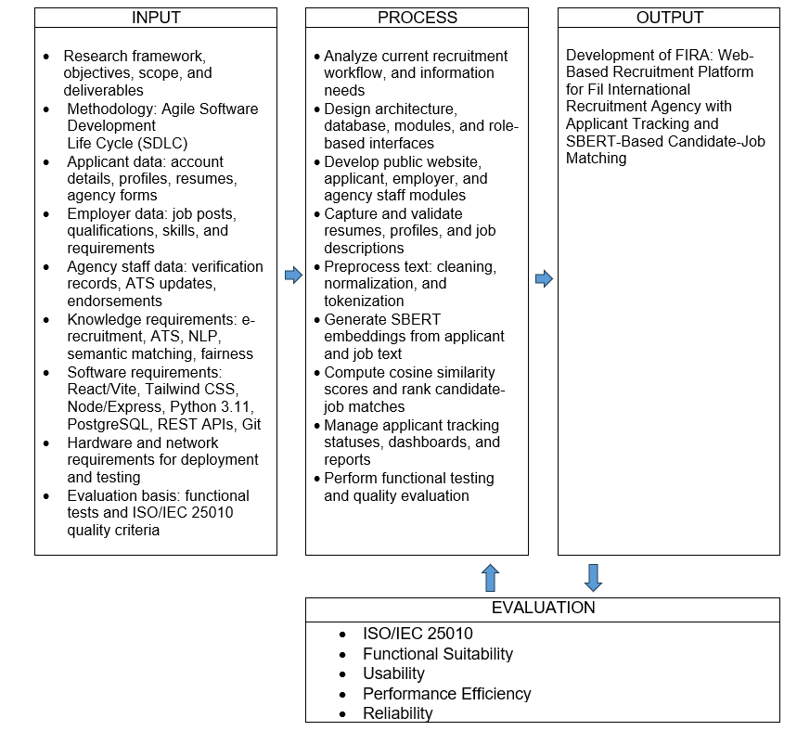

Deliverables

The following are the expected deliverables of the study:

- A responsive web-based recruitment platform prototype for an international recruitment agency.
- Public website pages, such as: Home, About, News, FAQ, Contact, and Job Search interfaces.
- Applicant, employer, and agency staff modules with role-based access and management functions.
- An Applicant Tracking System (ATS) for monitoring application progress and recruitment statuses.
- An SBERT-based candidate-job matching and ranking module for semantic recommendation and shortlisting support.
- System architecture, database design, technical documentation, test results, and evaluation findings.
References.

- Akkasi, A. (2024). Job description parsing with explainable transformer based ensemble models to extract the technical and non-technical skills. Natural Language Processing Journal, 9, 100102.
- Almeida, F., Junça Silva, A., Lopes, S. L., & Braz, I. (2025). Understanding recruiters’ acceptance of artificial intelligence: Insights from the technology acceptance model. Applied Sciences, 15(2), 746.
- Alonso, R., Dessì, D., Meloni, A., & Reforgiato Recupero, D. (2025). A novel approach for job matching and skill recommendation using transformers and the O*NET database. Big Data Research, 39, 100509.
- Bevara, R. V. K., Mannuru, N. R., Karedla, S. P., Lund, B., Xiao, T., Pasem, H., Dronavalli, S. C., & Rupeshkumar, S. (2025). Resume2Vec: Transforming applicant tracking systems with intelligent resume embeddings for precise candidate matching. Electronics, 14(4), 794.
- Çelik Ertuğrul, D., & Bitirim, S. (2025). Job recommender systems: A systematic literature review, applications, open issues, and challenges. Journal of Big Data, 12, 140.
- Hadžić, B. H. B., Brandner, L. T., Weber, T., & Rätsch, M. (2025). AI-driven active sourcing in recruitment: Addressing contestability in automated hiring systems. Frontiers in Computer Science, 7, 1629522.
- Horodyski, P. (2023). Applicants’ perception of artificial intelligence in the recruitment process. Computers in Human Behavior Reports, 11, 100303.
- Iso, H., Pezeshkpour, P., Bhutani, N., & Hruschka, E. (2025). Evaluating bias in LLMs for job-resume matching: Gender, race, and education. In Proceedings of the 2025 Conference of the Nations of the Americas Chapter of the Association for Computational Linguistics: Human Language Technologies (Volume 3: Industry Track) (pp. 672-683). Association for Computational Linguistics.
- Kumar, D., Grosz, T., Rekabsaz, N., Greif, E., & Schedl, M. (2023). Fairness of recommender systems in the recruitment domain: An analysis from technical and legal perspectives. Frontiers in Big Data, 6, 1245198.
- Ligeiro, N., Dias, I., & Moreira, A. (2024). Recruitment and selection process using artificial intelligence: How do candidates react? Administrative Sciences, 14(7), 155.
- Madanchian, M. (2024). From recruitment to retention: AI tools for human resource decision-making. Applied Sciences, 14(24), 11750.
- Mashayekhi, Y., Li, N., Kang, B., Lijffijt, J., & De Bie, T. (2024). A challenge-based survey of e-recruitment recommendation systems. ACM Computing Surveys, 56(10).
- Rosenberger, J., Wolfrum, L., Weinzierl, S., Kraus, M., & Zschech, P. (2025). CareerBERT: Matching resumes to ESCO jobs in a shared embedding space for generic job recommendations. Expert Systems with Applications, 275, 127043.
- Skondras, P., Zervas, P., & Tzimas, G. (2025). Zero-shot resume-job matching with LLMs via structured prompting and semantic embeddings. Electronics, 14(24), 4960.
- Tusquellas, N., Palau, R., & Santiago, R. (2024). Analysis of the potential of artificial intelligence for professional development and talent management: A systematic literature review. International Journal of Information Management Data Insights, 4(2), 100288.
- Xue, X., Wang, J., Ma, B., Ren, J., Zhang, W., Gao, S., Tian, M., Chang, Y., Wang, C., & Wang, H. (2025). Fine-grained semantics-enhanced graph neural network model for person-job fit. Entropy, 27(7), 703.
- Zhang, G., Pan, L., Tang, F., & Yao, F. (2025). Explainable artificial intelligence in the talent recruitment process: A literature review. Cogent Business & Management, 12(1), 2570881.

